September 7th, 2008
Hi
Well, in HK, today is Election Day for the Legislative Council. I will go and vote after I have sent this letter. I get only one vote now. In my CUHK days, I got two votes – one for the Geographical Constituency and one for the Functional constituency (Education). Now, I only get the former. It works on the proportional list system. For my constituency, there are 14 lists with candidates vying for the 8 seats available. Some of the lists have just one candidate, while others have the maximum of eight. The number of seats a list gets depends on the proportion of the vote it gets. But I do not know what happens in an extreme (but highly unlikely) case where everybody votes for the same list and that list has only one candidate on its list!! That list will only get one seat, so what happens to the other seven? The list I will vote for has three candidates, but will probably only get enough votes to elect the first person on the list.
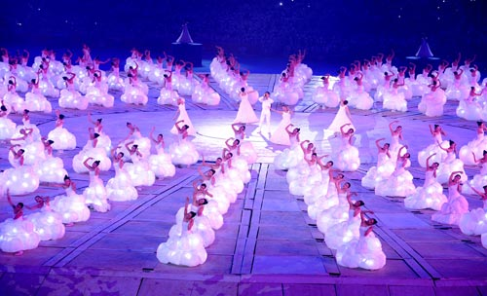
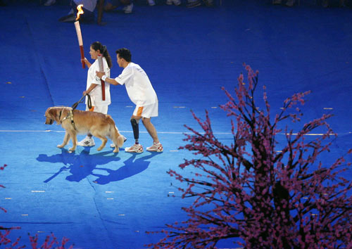
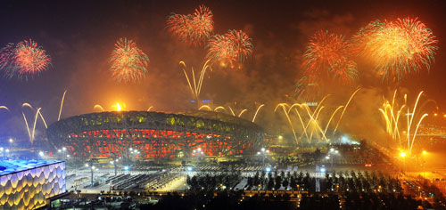
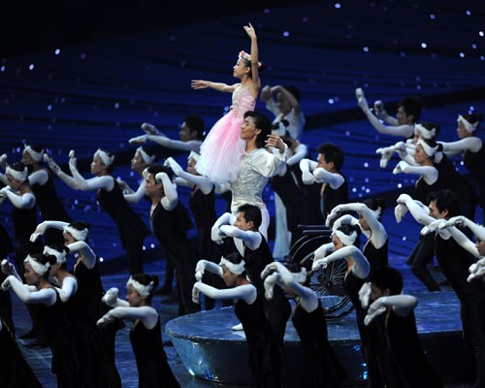
Last night I watched the opening ceremony of the Para-Olympics games. Pretty good though not quite as spectacular as the opening for the previous games. Comments/Observations:
- The HK flag bearer in the 100-metre world record holder (I did not know that before).
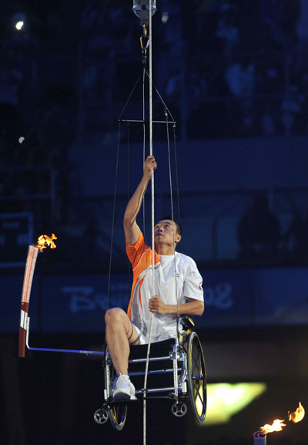
- Many of the people parading did not look handicapped to me (and they certainly were not all officials!). The commentators said that at previous games there has been controversy as to the status of some athletes.
- Many of the performances were by handicapped people. One was a 12-year old ballet dancer who lost a leg in the recent Sichuan earthquake, but performed in her wheelchair in a special ballet dance (second pic).
- I liked the dance by the girls who coordinated their movements with each other and with the music – remarkable as they are all deaf, and used sign language in the dance (third pic).
- There was only one glitch. In the final leg of the torch relay around the track, the torch of a blind girl (pictured with guide dog) would not light so the other athlete swapped torches (also in pic after swapping).
- The flame was lit by a man who, while in his wheelchair, pulled himself up a rope to the top of the stadium to light the fuse for the flame (see pic).
- Wheelchair Rugby is one of the events!! I don’t know how they play it.
- Only one para-athlete (I think) also participated in the Summer Olympics – a South African 10 000-metre swimmer. I will also be interested to see how Oscar Pitorius, the 400-m runner from SA who has prosthetic legs, gets on. I did not see him last night nor was there any comment about him, but I assume he is there.
These pictures are some of the many taken from the website:
http://en.paralympic.beijing2008.cn/ceremonies/photos/openingceremony/
While looking for pictures on the Internet, I came across a ‘Boston Globe’ website with many super pictures of the Summer Olympic Games. Take a look:
http://www.boston.com/bigpicture/2008/08/2008_olympics_opening_ceremony.html
I am now about halfway through Oliver North's ‘autobiography’ (though not actually written by him). Very interesting. However, he judges things from his very ‘conservative’ Republican viewpoint, often being very harsh on those who did not agree with him. He also explains most of his own actions in a light that makes him seem good. It is really necessary to read a version of what happened in the ‘Iran-contra’ affair from an impartial writer.
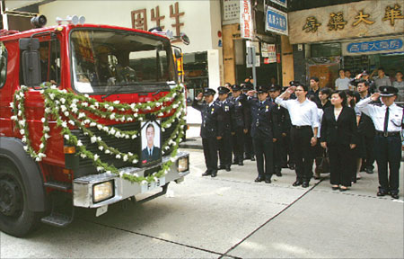
Back to HK again. The funeral was held the other day of one of two fireman killed in the recent high-rise building fire. He was buried in “Gallant Garden” in Fanling, the cemetery for civil servants who die in the line of duty. His death was partly due to being unable to contact colleagues using his radio, as the equipment was very old. The government has being trying to cut costs and this may be one of the consequences. A similar thing is happening in the Ambulance service with many ambulances breaking down as they are very old and the government won’t replace them. Also, a fireman’s union representative said yesterday that HK firemen have the longest working hours of any firemen in the world!!

Yesterday, there was some kind of workers' demonstration at the nearby building site I can see through the window. Police everywhere. Traffic had to be re-routed, as there was a group of people in the street together with a big protest banner (I think). After this, work on the building site stopped for the day.
On 20/20 the other night, there was a report on the US 'juicy campus' website and all the misery is has caused with people being able to write anything about other students with complete anonymity. Have any of you ever seen or heard of the website?

If things go according to plan (though there is not much of a plan at the moment) there should be no letters for the next two weeks as I should be in Indonesia. Similar to the visit in March promoting Science books though there will be more presentations that the one in March.
That seems to be it for now.

Cheers

